**DCS 2.8 Mi-24P Profile for TM Hotas Warthog**

* Functional layout
* Modifier
* Pedals required
* *TrackIR* required

**v1.0** =< GreaseLitenin >=

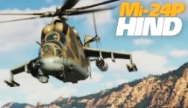

***AI COMMAND  
PILOT SIGHT***

***R-60***

|  |  |
| --- | --- |
| **Time Acc Time Dec Time Norm** | LCtrl + Z  LAlt + Z  LShift + Z |
| **Auto Start Auto End** | Win + Home  Win + End |

|  |  |
| --- | --- |
| **Act Pause**  **Pause** | LShift + Win + Pause  Pause |
| **Info Bar**  **Labels** | LCtrl + Y  LShift + F10 |
| **Pilot Body** | RShift + P |
| **Briefing** | LAlt + B |

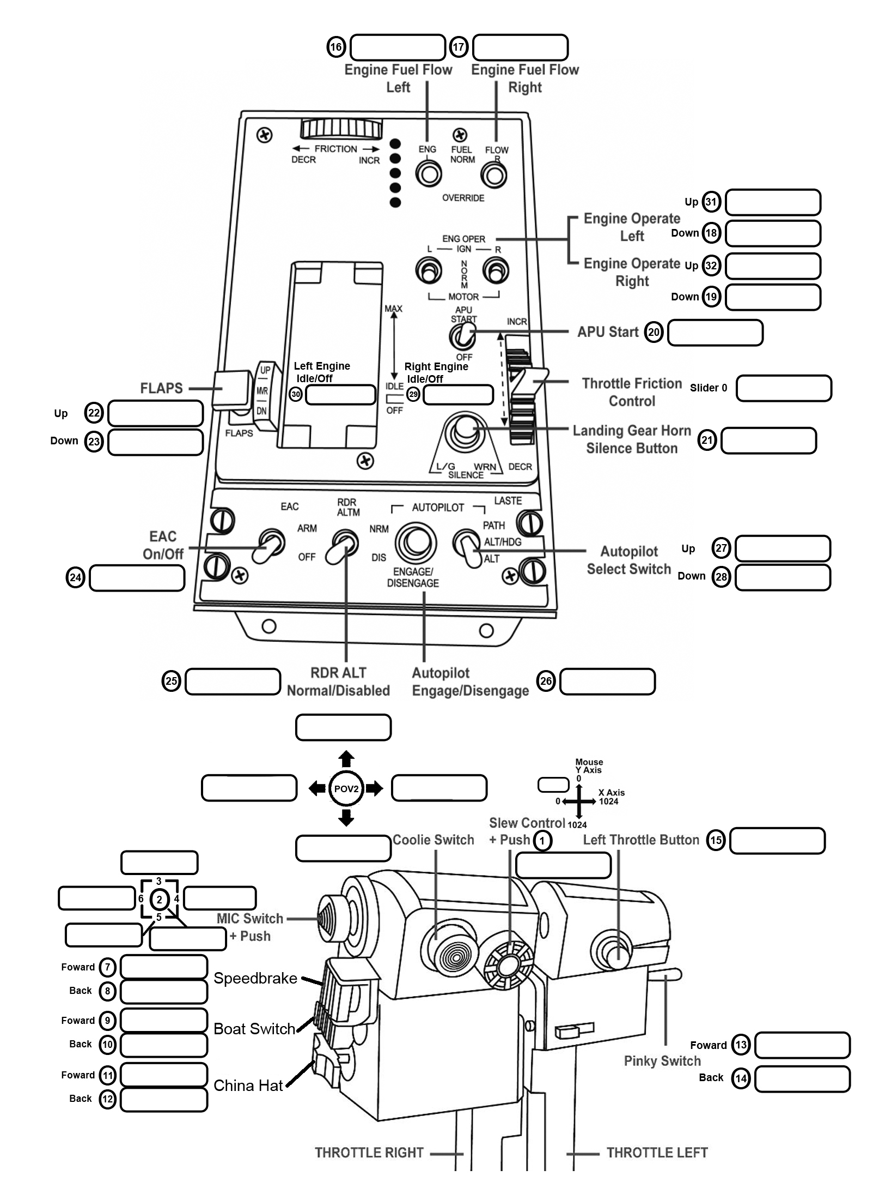

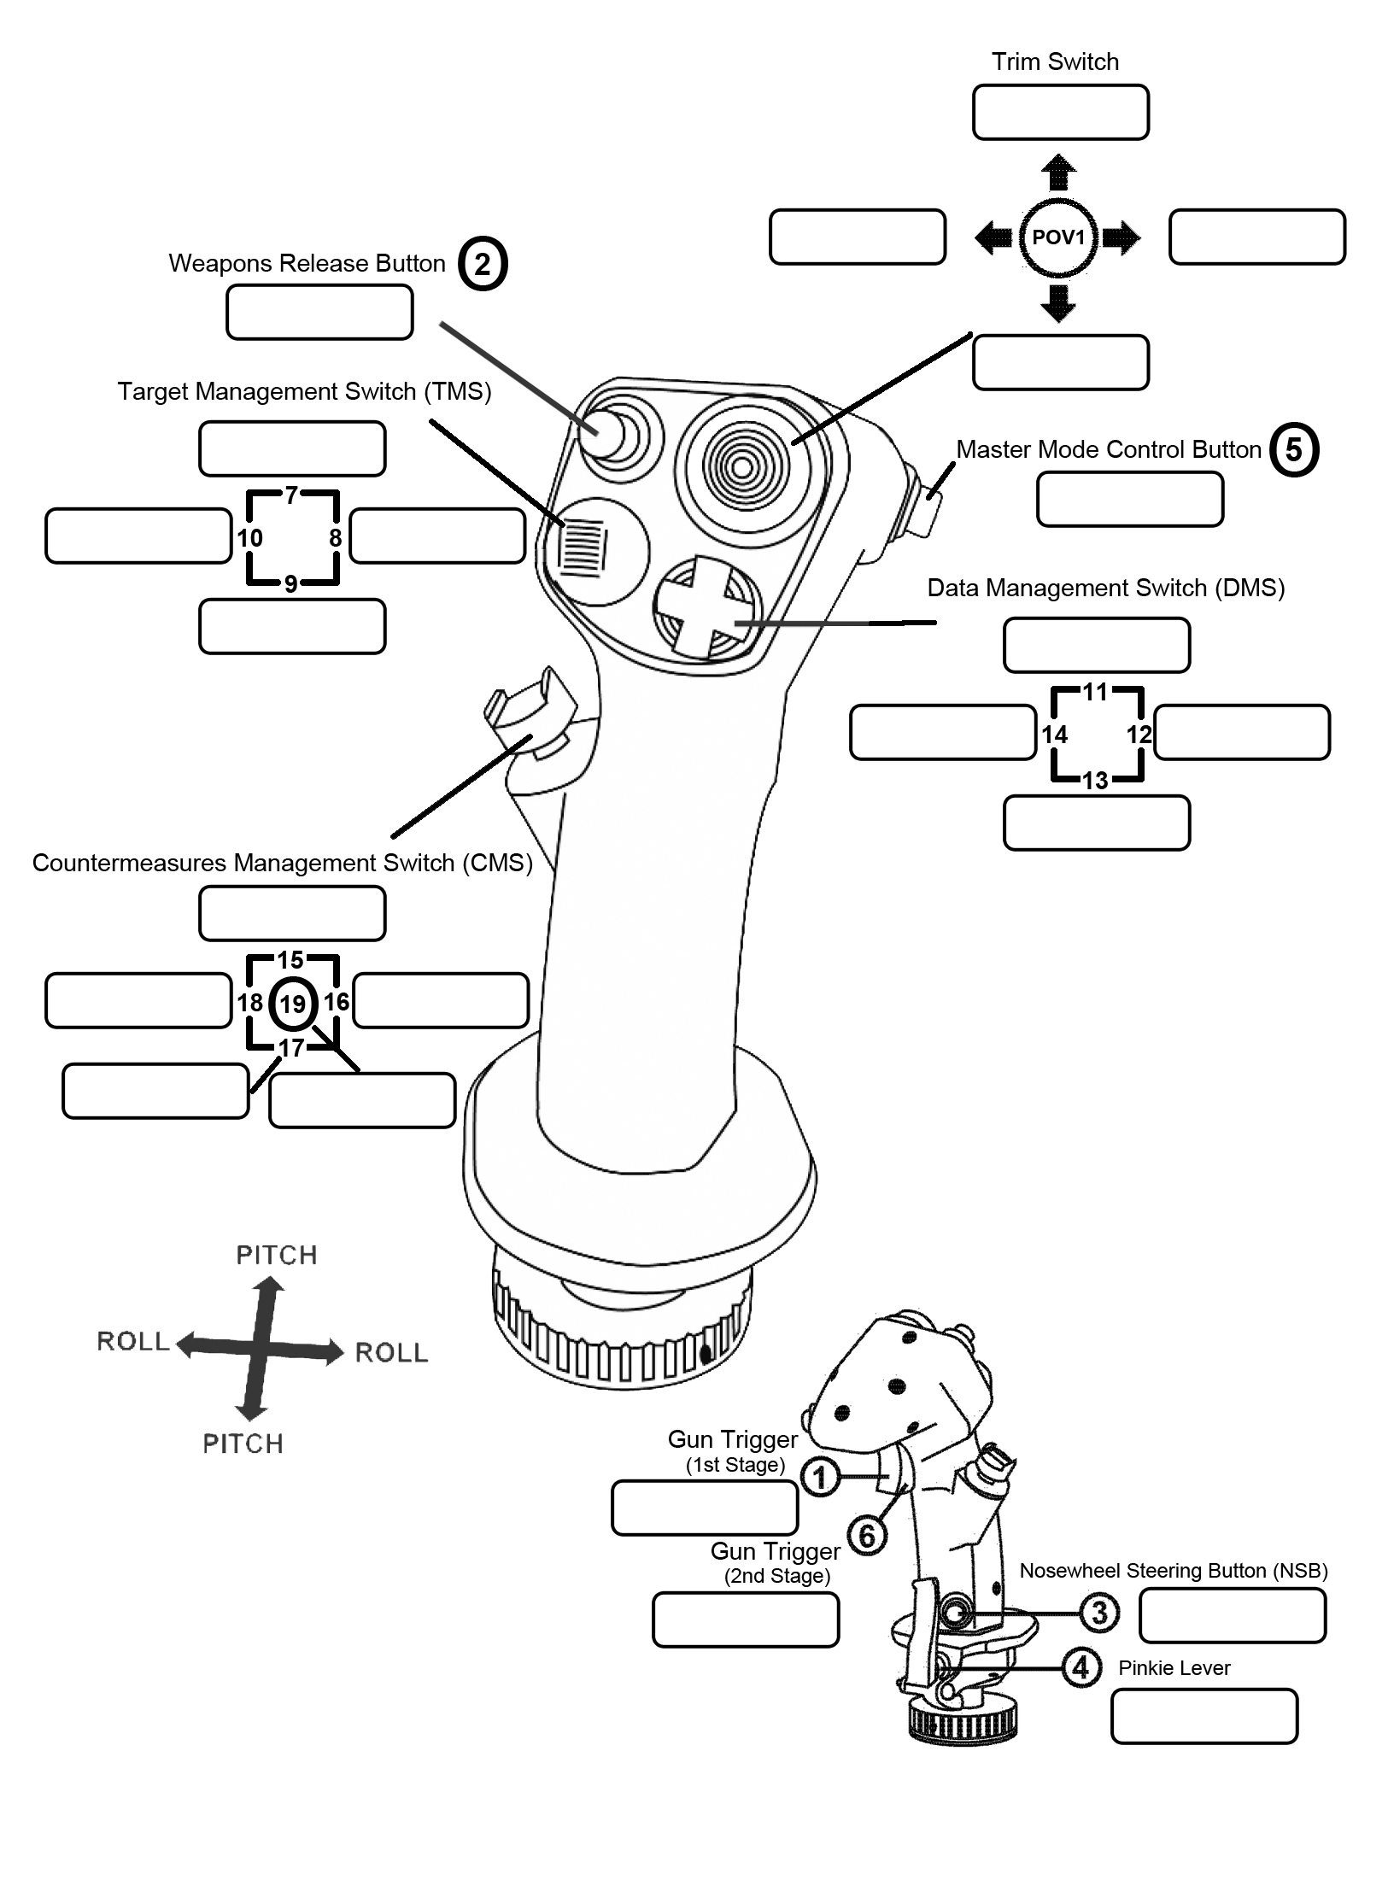

**PETROVICH (D)**

**SIGHT FXD BRT INC (P)**

**R-60 LNCHR SEL 2 (P)**

**PETROVICH (A)**

**SIGHT FXD BRT DEC (P)**

**R-60 LNCHR SEL 1 (P)**

**TRIM ROLL LEFT  
AP HOVER MODE ON (P)**

**TRIM ROLL RIGHT**

**AP ALT HOLD ON (P)**

**TRIM NOSE UP**

**AP ALT CHANNEL ON (P)**

**TRIM**

**TRIM RESET**

***KNEEBOARD, MAP  
9K113 AIMING STATION***

**TRIGGER (2nd Detent)**

**RELEASE WEAPONS (P)**

**FIRE ATG MISSILE (CPG)**

**SHOW/HIDE   
CYCLIC & COLLECTIVE (P)**

**WHEEL BRAKE (P)**

**REQ AIRCRAFT CTRL (CPG)**

**CONTROLS INDICATOR**

|  |  |  |  |
| --- | --- | --- | --- |
| **16** | **(P) SIGHT**  **↑SYNC ↓ASYNC** | **17** | **(P) SIGHT MODE**  **↑AUTO ↓MAN** |

**PETROVICH (W)**

**SIGHT GLASS FWD (P)**

**R-60 MODE AIR (P)**

|  |  |
| --- | --- |
| **NVG On/Off**  **NVG Gain ↑**  **NVG Gain ↓** | RShift + H  RShift + RCtrl + H  RShift + RAlt + H |
| **CPG Cyclic** | C |
| **Pilot HOCAS** | Backspace |
| **Controls Indicator** | RCtrl + Enter |
| **Flashlight** | Mouse Middle |

|  |  |  |  |
| --- | --- | --- | --- |
| **Left** | **Up** | **31** | **(P) CABIN LIGHT WHITE/RED**  **(P) LEFT PANEL RED LIGHT 2 INC**  **(CPG) LEFT ARC-15 RED LIGHT 1 INC|DEC** |
| **Dn** | **18** | **(P) BLADE TIP LIGHT ON/OFF** |
| **Right** | **Up** | **32** | **(P) MAIN/RIGHT PANELS RED LIGHT 1 INC**  **(P) FRONT INSTR PANEL RED LIGHT 3 INC**  **(CPG) MAIN PANELS RED LIGHT 2 INC|DEC** |
| **Dn** | **19** | **TAXI LIGHT ON/OFF**  **(P) STROBE LIGHT ON/OFF** |

**PETROVICH (P)**

**DESIGNATE TARGET/OPEN FIRE**

**PREPARE WEAPONS**

**9K113 AIMING STN (CPG)**

**PERISCOPE ON/OFF  
RELEASE RADIATE**

***LIGHTING***

**PETROVICH (S)**

**SIGHT GLASS AFT (P)**

**R-60 MODE GND (P)**

**BURST LENGTH NEXT  
MG CANNON RATE INC (P)**

**FXD MG30 CANNON RATE INC/DEC (CPG)**

**LAUNCH COUNTERMEASURES  
CPG SEAT (P)  
PILOT SEAT (CPG)**

|  |  |
| --- | --- |
| **20** | **(P) RWR SOUND ON/OFF** |

**WPN SEL KNOB PREV  
RCKT SEL SWITCH LEFT (P)**

**LNCHR ROTARY PREV (CPG)**

**WPN SEL KNOB NEXT   
RCKT SEL SWITCH RIGHT (P)**

**LNCHR ROTARY NEXT (CPG)**

**KNEEBOARD ON/OFF (P)  
🡹 MAP OWN POS (P)**

**9K113 AIMING STN (CPG)**

**ZOOM X3/X10  
OBSERVE (B2) ON**

|  |  |  |
| --- | --- | --- |
| **GEAR LEVER** | | |
| **Up** | **22** | **UP** |
| **Mid** | **-** | **-** |
| **Dn** | **23** | **DOWN** |

**BURST LENGTH PREV**

**MG CANNON RATE DEC (P)**

**FXD MG30 CANNON RELOAD (CPG)**

POWER LEVER

**THROTTLE (P)  
(COLLECTIVE)**

**Throttle Mode**

**(P) EXT CARGO**

**TACT UNHOOK**

**SET HOOK**

**KNEEBOARD PREV PG (P)  
🡸 MAP OWN POS (P)**

**9K113 AIMING STN (CPG)**

**HELP ARROW**

**MISSILE SIGHT DOORS**

**KNEEBOARD NEXT PG (P)  
🡺 MAP OWN POS (P)**

**9K113 AIMING STN (CPG)**

**BACKLIGHT (B4)**

**USER HINTS**

***WEAPONS***

**KNEEBOARD POS MARK (P)   
🡻 MAP OWN POS (P)**

**9K113 AIMING STN (CPG)**

**SLEW TO CENTER  
OBSERVE (B2) OFF**

*CPG Aiming Station: Assign X and Y axis for L/R and Up/Down*

***TRIM***

***AUTOPILOT***

|  |  |  |
| --- | --- | --- |
| **NVG BRIGHTNESS** | | |
| **Up** | **27** | **GAIN UP** |
| **Dn** | **28** | **GAIN DN** |

**(P) MAIN**

**FIRE CTRL**

**↑ON ↓OFF**

**TRIM NOSE DOWN**

**AP ROUTE MODE ON (P)**

|  |  |
| --- | --- |
| **AXIS TUNE** | |
| **Cyclic**  **Pitch|Roll** | Dzone 0, Curve 15 Sat X100 Y90 |
| **Collective**  **& Pedals** | Dzone 0, Curve 10  Sat X100 Y100 |
| **Slider** | Dzone 15, Curve 0 Sat X70 Y100, Slider |

**(P) SIGHT RANGE ↑AUTO ↓MAN**

**NVG**

CYCLIC

***ZOOM  
HEADLIGHT***

**ZOOM IN SLOW  
HEADLIGHT UP**

***ICS/RADIO COMMS***

***AI INTERFACE***

**HEADLIGHT CTRL**

**HEADLIGHT RIGHT**

**HEADLIGHT RETRACT**

**HEADLIGHT LEFT**

**FLT ATTK AIR DEFENSES**

**FLT JOIN UP**

|  |  |
| --- | --- |
| **Jump to Aircraft** | RAlt + J |
| **Respawn** | RCtrl + RShift + Tab |
| **Framerate** | RCtrl + Pause |

**RADIO**

**FLT COVER ME**

**ICS**

**FLT ENGAGE BANDITS**

**FLT ATTK GND TGTS**

**FLT ATTK PRIMARY**

**TGT & REJOIN**

**Slew Control + Push**

**ZOOM OUT SLOW  
HEADLIGHT DOWN**

**MODIFIER**

**Button**

(unassign slew axes)

|  |  |
| --- | --- |
| **Kneeboard ON/OFF** | RShift + K |
| **Kneeboard Next Page** | ] |
| **Kneeboard Prev Page** | [ |
| **Kneeboard Mark Current Position (Map)** | RCtrl + K |

*Removing   
‘safety cover‘*

*not necessary*

*CPG can only operate USLP*

*via USLP*

*buttons*

*Bombs & rockets must be loaded symmetrically*

|  |
| --- |
| **TRACK IR RECENTER** |
| **COCKPIT VIEW** |

**AI INTERFACE SHOW/HIDE**

**AUTOPILOT**

**DISENGAGE (P)**

**PARKING BRAKE (P)**

**COUNTERMEASURES   
SET I/II/III (CPG)**

**TRIGGER (1st Detent)**

**RELEASE WEAPONS  
USLP DISCONT (P)**

|  |  |  |  |
| --- | --- | --- | --- |
| **Fwd** | **7** | **(P) AP PITCH CHANNEL ON|OFF**  **(CPG) BOMB PODS NEXT|COVER** | **AUTOPILOT**  **BOMB PODS** |
| **Aft** | **8** | **(P) AP ROLL CHANNEL ON|OFF**  **(CPG) BOMB PODS PREV|COVER** |
| **Fwd** | **9** | **(P) AP ALT CHANNEL ON|OFF**  **(CPG) WPN CTRL ASSUMED UP|COVER OPEN** | **AUTOPILOT WPN CTRL** |
| **Aft** | **10** | **(P) AP YAW CHANNEL ON|OFF**  **(CPG) WPN CTRL ASSUMED DOWN|COVER CLOSE** |
| **Fwd** | **11** | **(P) AP SPEED STABLILIZE ON**  **(CPG) USLP OPER**  **ACTIVE PAUSE** | **AUTOPILOT**  **USLP** |
| **Aft** | **12** | **(P) AP SPEED STABLILIZE OFF (CPG) USLP DISCONT  BRIEFING** |

**Coolie Switch**

|  |  |
| --- | --- |
| **LEGEND** | |
| **PILOT/CPG** |  |
| **PILOT/CPG + Modifier** |  |

|  |  |  |
| --- | --- | --- |
| **Pinky**  **Switch** | | **ENGINE TRIM**  **(TURBINE RPM)** |
| **Fwd** | **13** | **DEC** |
| **Aft** | **14** | **INC** |

**Speedbrake**

**Boat Switch**

**China Hat**

COLLECTIVE

COLLECTIVE